(Attached to the end of this report is a copy of the FAA Special Airworthiness Information Bulletin CE-09-23.)

An A&P mechanic writes, "This aircraft underwent full restoration; the original steel fuel tank was used which was in excellent condition. The tank was prepped and Randolph sloshing compound was applied IAW the manufacturer's instructions. This tank was sloshed to seal any pinholes in the tank—common for its age and material. Ten months after it was put back into service, the aircraft had accumulated 6.0 hours since restoration with no abnormalities. Shortly after (this next) takeoff the engine quit—the pilot landed on the remaining part of the runway. This aircraft sustained major damage during the forced landing. Upon investigation with the FAA, the carburetor and gascolator screens (were found to have) small white/amber flakes. The fuel tank had a sump at the bottom of the tank similar in size to an aluminum Cessna Gascolator. Fittings were removed from the sump and a large amount of white/amber flakes were visible through the holes. The top of this fuel tank has a large access port; once removed the sides of the tank and the sump were (both) visible through the baffles. The sump was 75% full of flakes and large portions of the sloshing compound were missing from the sides of the tank. The size of the flakes varied from pencil lead to 2 or 3 inch diameter flakes. The aircraft had been serviced only with 100LL.

"In my opinion, I feel the engine quit due to fuel starvation from the tank sloshing compound breaking off in large quantities and blocking the outlets of the fuel tank. It is obvious the sealant is failing to adhere to the sides of the tank, regardless of the preparation techniques directed by the manufacturer. To prevent similar occurrences that could result in loss of life, I would recommend the following: 1) (do not) use any sort of fuel sloshing compound in any part of the fuel system. 2) Ensure a finger strainer is installed in each outlet of each tank. 3) Remove any tank from service and replace if it has been treated. 4) Closely monitor the fuel screens and outlets if a tank was treated with this product until replacement can occur. Piper Aircraft Service Bulletin 251D is a great reference to the use of Randolph Tank Sloshing Compound. Piper recommends removing and replacing a fuel tank that has been treated with this product."

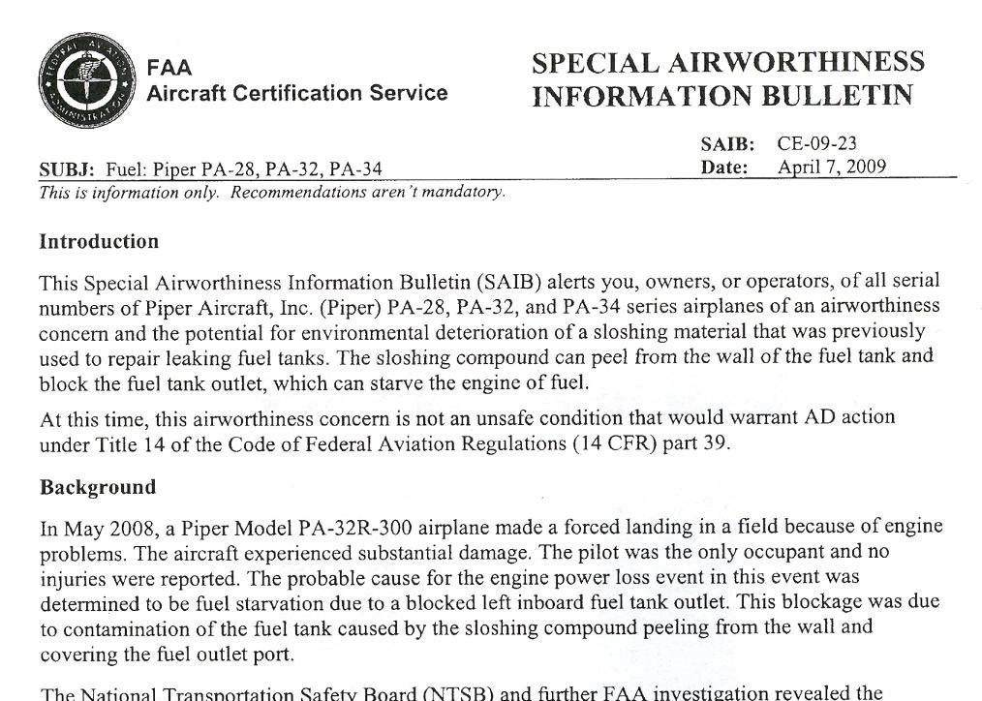

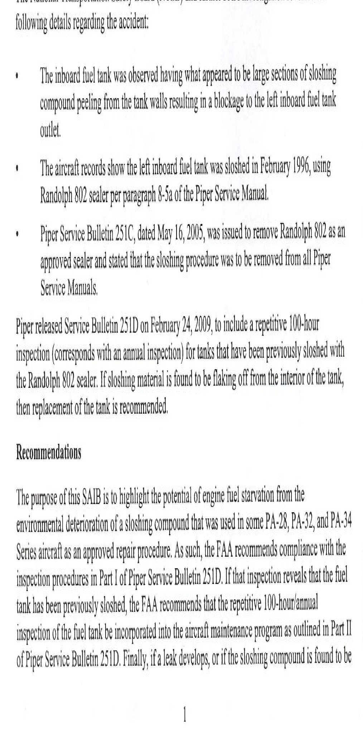

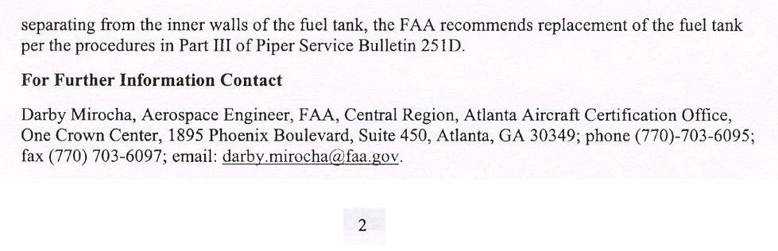

Part Total Time: 6.0 hours